 |  | AHE Learning  & Teaching Support Unit
Setting up an Online Office Hours Sign-up Sheet
This help document gives step-by-step instructions for setting up an Online Office Hours Sign-up Sheet using Google accounts and a service YouCanBook.Me. It is divided into five main sections:
- Setting up a Google account
- Setting up the Google calendar
- Adding the YouCanBook.Me account
This process requires about 15 – 25 minutes to setup but will then only need minor maintenance. A further guide will cover Viewing Office Hours bookings and Managing your office hours.
- Setting up a Google account
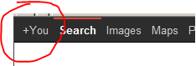
If you already have a Google account you can use it instead of setting up a new account (go to step 2). If you need to setup a Google account then follow the steps below.
- Go to http://google.co.uk/ and click on the +You link in the top left of the page
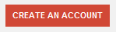
- On the next page click on the CREATE AN ACCOUNT button in the top right of the page
- In the next screen add in the essential details required (you do not need to enter a Mobile phone number and nor do you need to Set Google as my default home page).
Note: If you don't have a preferred username we suggest that use your NTU Username when you Choose your username for the Google account. Of course, it goes without saying that you must not use the same password as you use with the NTU username. You will need to remember the Google account details to maintain your office hour availability.
Enter your NTU email address for the box labelled Your current email address.
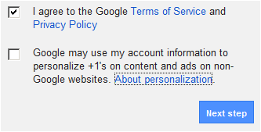
- Finally tick to accept the Google terms of Service and Privacy Policy and leave the next box for personalisation unticked and click on the Next step button.
- The next page will allow you to edit your Google account Profile. This is not necessary. Click on the Continue to Google+ button.
- Check your NTU email account where there should be a message from account-verification-noreply@google.com to verify that you want to associate your NTU email address with the Google account. Click on the verification link.
- Following the link in step 6 will open up a new Google window where you will have the option to enhance your profile. None of this is necessary and you can click on all Continue or Continue anyway buttons until you get to the Finish button and click on that as well.
- You should now be at the Dashboard or Home page of your Google account. Towards the top right corner of the window you will see icons for the management of your Google account.
The bell links to notifications from Google about the account.
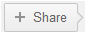 The sharing icon opens a window with sharing options (not needed for the sign-up sheet).
 The profile icon allows you to view/edit your account and add other accounts
- Setting up the Google calendar
Now that you have your Google account you need to add your office hours to a Google Calendar. The following steps go through the process.
- Log into your Google account, if not already there. Click on the Calendar link in the black bar at the top of the screen
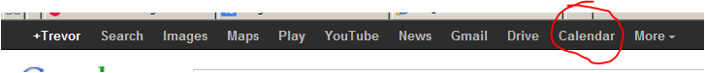
- If it is the first time you have clicked opened a Google Calendar you will see a welcome message and you can set the Calendar to English (UK). Carry on through the settings until you get to the Calendar view.
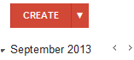
- You will already have a Calendar labelled with your name. You can use this Calendar to set up the times for your Office Hours. (If you are already using this calendar for your personal use then you can create another Calendar specifically for your NTU Office Hours).
- Click on the Create button to add a new appointment to the Calendar.
- In the next screen you can set up the parameters for the Office Hours slot. Leave all the default settings except those identified below:
  - Enter the text Office Hours in the first box for the appointment title. This text is important as it will be used to identify the times that students can book in to see you.
  - Enter the first office hours session (Date, Start time and Finish time)
  - Tick the Repeat… option and in the pop-up dialogue box and set the number of repetitions you want to set up (After 10 occurrences will go to the end of the first term for example)
  - Enter your office number in the Where box
  - If you have created extra calendars make sure the correct calendar is selected from the drop-down list
  - Select the Show me as available option
Your form should look something like the screenshot below:
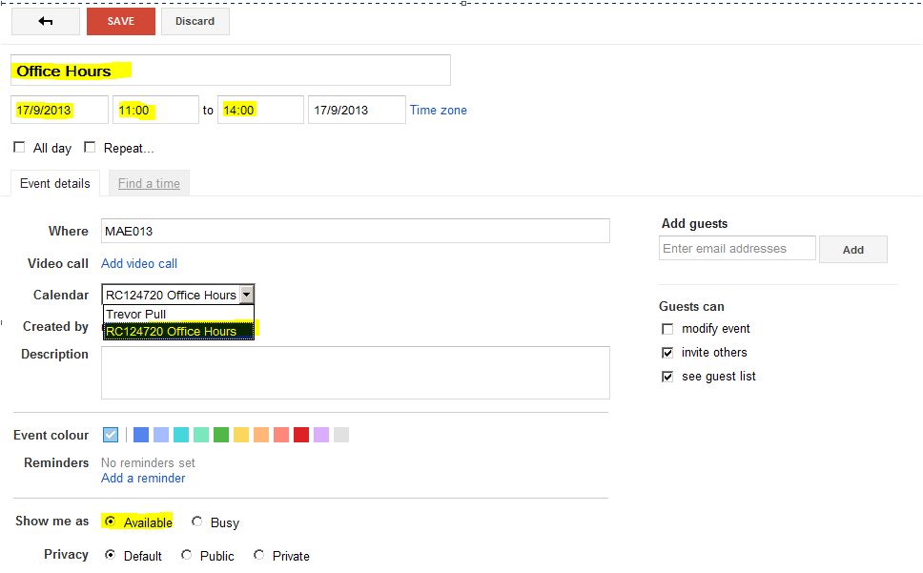
- Now click on the SAVE button at the top of the form.
Repeat these steps for additional office hour sessions
- Adding the YouCanBook.Me account
The YouCanBook.Me service uses the Google Calendar to populate an online booking form. The advantages of this service over other online booking solutions tried in the school is that the booking information is stored in your Google Calendar which is a robust external service as well as one that emails both the student and lecturer details of each booking so it is highly unlikely that booking information will be lost.
Setting up the YouCanBook.Me service is only done once, so although it is fairly lengthy it is not repeated.
- Keep the Google account open or login to the Google account
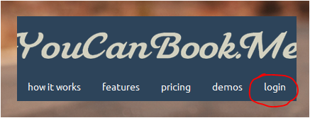
- In a new tab or window for your browser, go to the http://YouCanBook.Me site
- On the home page there is a login link. Click on this to login using your Google account.
- The first option for the login is in a tab labelled via Google. Click on the Google logo to open up a pop-up window and click on the Accept button to allow Youcanbook.me service to view your Google email address.
- The next screen is to link the your Google Calendar – click on the Google logo again which will open up another pop-up window requesting permission to Manage your calendars. Click on the Allow access button.
- Next you will be taken through a four step basic set up process
Step 1 – Enter the text Office Hours – {Your Name} where it asks for the name of your organisation (this text will appear at the top of all the pages concerned with the online booking process)
Step 2 – leave as the default value unless you have a strong desire to change it
Step 3 – Set the Start and End time of the grid in which your office hours will display e.g. if you have 11:00 – 12:00 on a Tuesday and 15:00 – 16:00 on a Thursday you will need to have the start time as 11:00 and the finish time as 16:00 so the grid can accommodate your office hours. Be assured that only the times marked Office Hours in the Google account will show as bookable.
Next, set the time for a single slot – normally this will be either 10 or 15 minutes.
Step 4 – Here you will choose a theme for the display of the booking form. For conformity across the school we recommend choosing the fifth option as it will keep the pages shorter with so many bookable slots
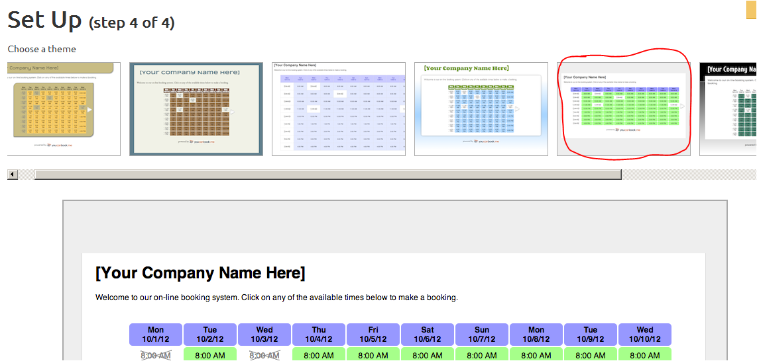
Clicking on the theme will complete the basic set up.
Now you need to set up the actual booking form and email messages produced by the form.
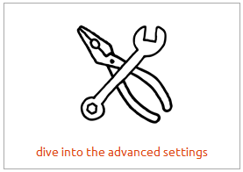
- From the screen click on the dive into the advanced settings button.
Alternatively you can access the Settings by going to the dashboard link in the blue bar at the top of the screen, then choosing manage and then clicking on the launch settings editor button
- This will bring up a screen with fourteen tabs and the first one labelled basic will be highlighted.
Note: You will only need to edit the settings in seven of the tabs as the rest are either unnecessary or only available for users who have paid for the premium account. Edits are auto saved at regular intervals although there is a save now link that appears in the top right of the window if there are unsaved changes that you can use to force a save in order to update the preview that appears at the bottom of each of the settings pages.
The basic tab
- In the basic tab, firstly check that the correct Google Calendar is selected – use the change button if you need to change it (this is only necessary if you created a separate calendar for the Office Hours in your Google account)
- Move down to the box labelled text at the top of the booking grid and add text to instruct your students on how to use the booking form. You can cut and paste our suggested text:
Please choose an available slot from the list below. You can book up to two weeks in advance. Please keep your bookings to a single slot except dissertation students who can book two slots together.
- Tick the online option to make the booking form useable.
- Now move to the times tab.
The times tab
- These settings concern the booking grid. Firstly, check that the start and finish times are set for the Monday to the Friday – these should already be entered from your basic set up.
- Leave the five week days ticked but untick Saturday and Sunday.
- Change the option for unchecked days to hide completely in the drop-down menu.
- In the right hand column change the maximum booking to double the default booking time i.e. if your normal slot is 10 minutes change the value for the maximum booking to 20 minutes.
- Change the display: option to show 2 weeks.
- Select on a Monday from the drop-down menu labelled starting.
- The next step is important for the booking form to function properly. In the on duty events box type the text Office Hours. This must be an exact match with the title text used when you created your Office Hours slots in the Google calendar.
- Now go to the advanced tab.
The advanced tab
- There are a just two things to edit on this tab. Firstly, change the minimum notice value to 1 hour(s).
- Set the maximum advance booking value to 2 weeks.
- Go to the booking form tab.
The booking form tab
This determines the layout of the form that is displayed once the student has chosen the time slot for their appointment. There are four sections in the default display, Booking:, Your Email:, Notes: and Duration:
You can be creative with this and add your own questions and/or rearrange the order of the questions but it is enough if you only edit Your Email:, Notes:.and Duration:.
- Click on the sign against the Your Email: heading to expand the setup options.
- Go to the text box labelled text after: and enter the suggested text below:
(A confirmation message will be sent to this address which will include instructions for cancelling the appointment should that be necessary - please do not delete the email until the appointment has passed).
- Make sure that the option this is a required field is ticked. It should look something like the screen shot below:
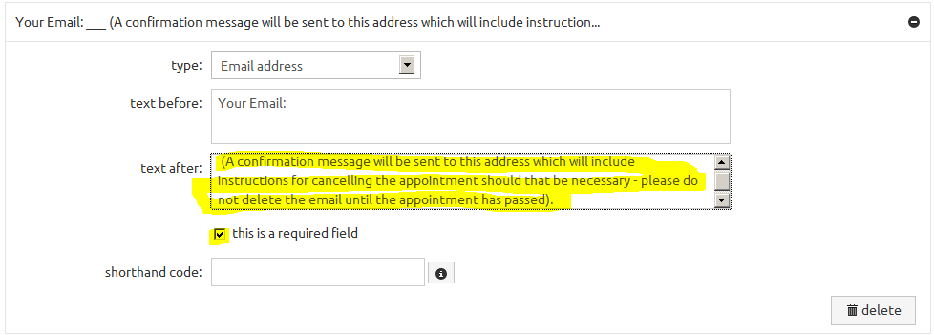
- Expand the set up options for Notes: by clicking on its sign. In the text before: box delete the Notes and add the suggested text below:
Please give an indication of what you would like to discuss in this session:
- Lastly, expand the Duration: set up options and add the suggested text below to the text after: box.
(Dissertation students can book a double session - all other students should book a single slot of 10/15 minutes).
- Go to the afterwards tab.
The afterwards tab
This tab has sub-sections listed on the left hand side.
- Start with the messages sub-section and add the suggested text below to the message text box:
Thank you.
A confirmation email has been sent to the address you entered in the form to confirm the booking. The email also contains information about cancelling the appointment should you need to do so. Please do not delete the email until the appointment has passed.
- Go to the email to you sub-section on the left and check that the email alert to you: option is ticked and then edit the to email address: by entering your NTU email address instead of the gmail address.
Note: You can enter multiple email addresses by separating them with a comma should you want a copy of the booking email confirmation to go to a different address as well as your NTU email.
- Now go to the email to user: sub-section on the left and start by adding your name to the from name: box.
- Then change the from address: to your NTU email address.
- Finally, tick the attach ics/ical: option even though it does warn you to use this with caution.
(This will give those student who know how to use the ics/ical files to add the booking into their calendar).
- Now go to the cancellation tab.
The cancellation tab
Again, this tab has three sub-sections but only the first sub-section, limits, is applicable to free accounts.
- Check that the allow cancellations option is ticked and change the up to: value to 0 hours before the start of the booking.
This seems to be the most sensible option as it will allow students to inform you if they can't make it to a session because they are running late etc.
- Now go to the final settings tab labelled appearance.
The appearance tab
This final tab has sub-sections but you only need to edit the first sub-section labelled header/footer.
- In the footer: box add the suggested text:
School of Arts and Humanities, Nottingham Trent University
- Click on the save now link in the top right corner of the window if it is showing or wait until the preview at the bottom of the screen refreshes to show the addition of the footer text.
- That completes the setting up process and congratulations for making it this far.
Now all you need is the URL that you can add to content, widgets or news items in NOW, or to add to your email footer (or in a straight email) etc.
- To get the address click on the dashboard link in the blue bar at the top of the screen and choose publish from the drop-down menu.
- In the next screen you will see many ways of sharing the URL for your booking form. The first option share a link will allow you to copy the URL.
- If you feel confident with the idea of embedding code in a page in NOW then the third option embed on your web site will give you the code to copy and insert in the page. It is important to remember that the booking form is not from a secure web site and therefore some browsers may block the non-secure elements of the page i.e. the booking form.

Colleagues in the schools of Arts & Humanities and Education are welcome to contact the LTSU for help with the setting up of online Office Hours booking forms.
Other colleagues around the University are welcome to use this guide 'as is' but it is not supported by central services at the time of writing.

